Software Test Plan

for

**Online Educational Forum [Study-Buddy]**

Version 1.0 approved

**Prepared by**

Kainath,MD. Tazul Islam

Mustaq, Sufian

Irina,Sumaya Naznin

Kha,Dipty Moni

Department of Science and Technology

18-04-22

**Table of Contents**

Revision History 3

1. TEST PLAN IDENTIFIER: RS-MTP01.3 3

2. REFERENCES 3

3. INTRODUCTION 3

Background to the Problem 3

Solution to the Problem 4

4. REQUEIREMNT SPECIFICATION 4

4.1 System Features 4

4.2 System Quality Attributes 4

4.3 System Interface 5

4.4 Project Requirements 5

5. FEATURES NOT TO BE TESTED 5

6. TESTING APPROACH 5

6.1 Testing Levels 5

6.2 Test Tools 6

6.3 Meetings 6

7. TEST CASES/TEST ITEMS 6

8. ITEM PASS/FAIL CRITERIA 7

9. TEST DELIVERABLES 7

10. STAFFING AND TRAINING NEEDS 8

11. RESPONSIBILITIES 8

12. TESTING SCHEDULE 8

13. PLANNING RISKS AND CONTINGENCIES 9

14. APROVALS 9

# Revision History

|  |  |  |  |
| --- | --- | --- | --- |
| Revision | Date | Updated by | Update Comments |
| 0.1 | 16-04-2022 | Irina | 1st Draft |
| 0.2 | 16-04-2022 | Dipty | 2nd Draft |
| 0.3 | 17-04-2022 | Tazul | 3rd Draft |
| 0.4 | 18-04-2022 | Sufian | 4th Draft |
| 0.5 | 18-04-2022 | Tazul | 5th Draft |
| 0.6 | 19-04-2022 | Sufian | 6th Draft |
| 0.7 | 20-04-2022 | Irina | 7th Draft |
| 0.9 | 20-04-2022 | Dipty | 8th Draft |
| 0.10 | 20-04-2022 | Sufian | 9th Draft |

# TEST PLAN IDENTIFIER:RS-MTP01.3

# REFERENCES

* Software Requirement Engineering Document
* Software Testing and Quality Assurance – Theory and Practice - Kshirasagar Naik & Priyadarshi Tripathy
* Software Quality Engineering: Testing, Quality Assurance and Quantifiable Improvement - Jeff Tian
* Selenium tool
* Figma
* thefinancialexpress.news (website)

# INTRODUCTION

## Background to the Problem

Students of days face a slew of issues when it comes to completing or studying anything. Sometimes they are unable to tackle difficult tasks on their own and want assistance. However, when a work is required in a short amount of time and with a large number of needs, it is quite difficult to locate someone who can assist in solving the issue. As a result, pupils are unable to fully prepare for exams.

This may be seen as an issue by students. However, as our nation evolves, we will need to upgrade a system to assist with online education resources. The majority of instructional resources are now available on the internet. If a student's difficulty is solved, it might be considered a success, and pupils will benefit as well.

## Solution to the Problem

This project will be developed with the intention of serving as an invaluable resource for students who are experiencing academic difficulties. People who are experts in a certain field may visit this site, as well as users who are experiencing difficulties and seeking answers. In exchange, a user who solves an issue for another user may be compensated with a fee.

The advantages of utilizing online discussion forums and peer-to-peer learning to improve student learning are extensively documented. Apart from full-fledged online courses, its use in conventional learning settings to supplement face-to-face instruction is growing, and it has now become a popular educational method in higher education. In fact, there is a growing interest in utilizing an online discussion forum as a gauge of a student's performance. Online discussion forums are anticipated to allow for flexible and autonomous learning as well as the development of critical thinking abilities. However, there are certain issues, such as learners' lack of attention and insufficient reflection, students' failure to react to others' views, and superficial debates. Students' usage of online discussion forums in the context of their studies, as well as the qualities of a successful online discussion environment that support effective learning, need to be researched.

Study-Buddy aspires to be one of Bangladesh's top platforms for students to develop a vast community and grow a great country with highly educated leaders together.

# REQUEIREMNT SPECIFICATION

## System Features

|  |  |  |  |  |
| --- | --- | --- | --- | --- |
| **Requirement ID** | **Date** | **Requirement**  **Description** | **Dependencies** | **Originator** |
| FR-01 | 16-04-22 | Registers new user and stores their credentials in the database. | User need have valid email ID, Phone Number. | Senior Developer |
| FR-02 | 16-04-22 | authenticate valid users of the system and logs them in. | Must be a registered user. | Senior Developer |
| FR-03 | 16-04-22 | Updates user information in the database. | Must be a registered user. | Senior Developer |
| FR-04 | 17-04-22 | Takes user posts as parameter and stores them in the database | Must be a valid post. | Junior Developer |
| FR-05 | 17-04-22 | Display all problems in the dashboard. | Database | Junior Developer |
| FR-06 | 17-04-22 | Admins can delete users, delete posts, block users. | Database | Junior Developer |

Table -1

## System Quality Attributes

|  |  |  |  |  |
| --- | --- | --- | --- | --- |
| **Requirement ID** | **Date** | **Requirement**  **Description** | **Dependencies** | **Originator** |
| NF-0.R1 | 18-04-22 | Security | Program | Senior Developer |
| NF-0.R2 | 18-04-22 | Usability | Program | Junior Developer |
| NF-0.R3 | 18-04-22 | Maintainability | Program | Junior Developer |
| NF-0.R4 | 18-04-22 | Scalability | Program | Junior Developer |
| NF-0.R5 | 18-04-22 | Performance | Program | Junior Developer |
| NF-0.R6 | 18-04-22 | Reliability | Program | Senior Developer |

Table - 2

## System Interface

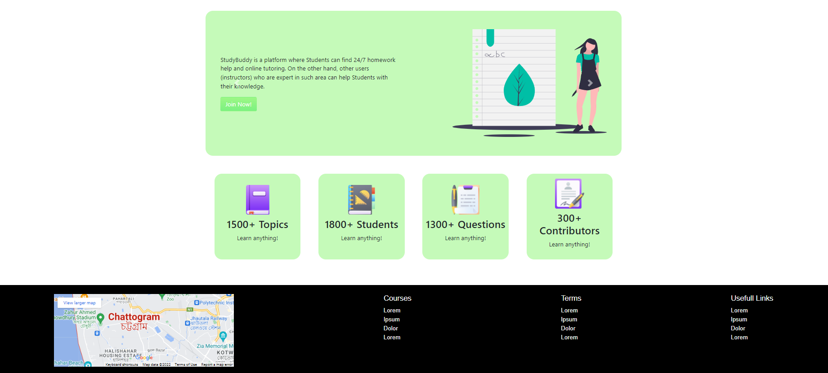

Figure-1 (Dashboard)

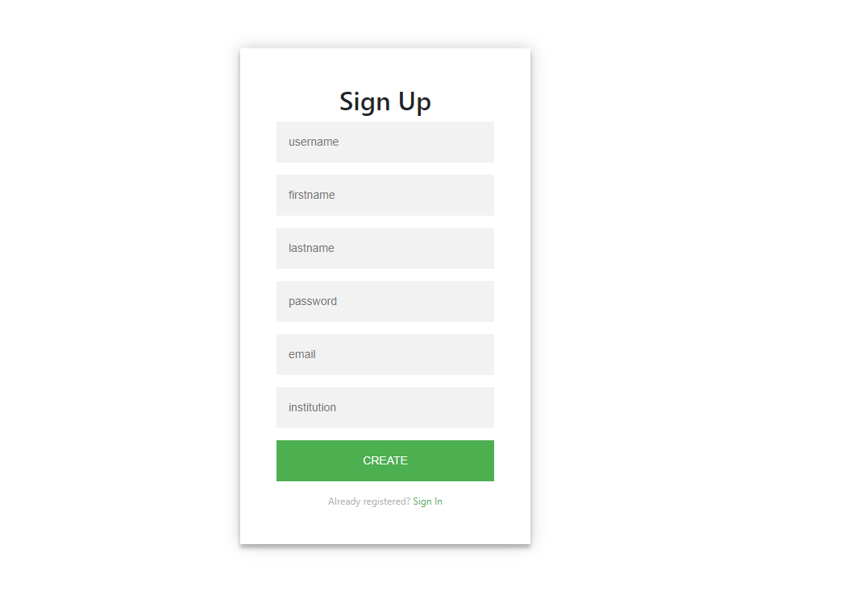

Figure-2(Registration Page)

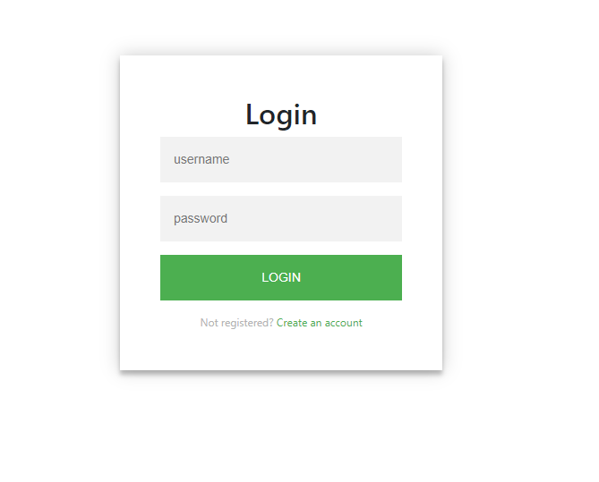

Figure-3 (Login)

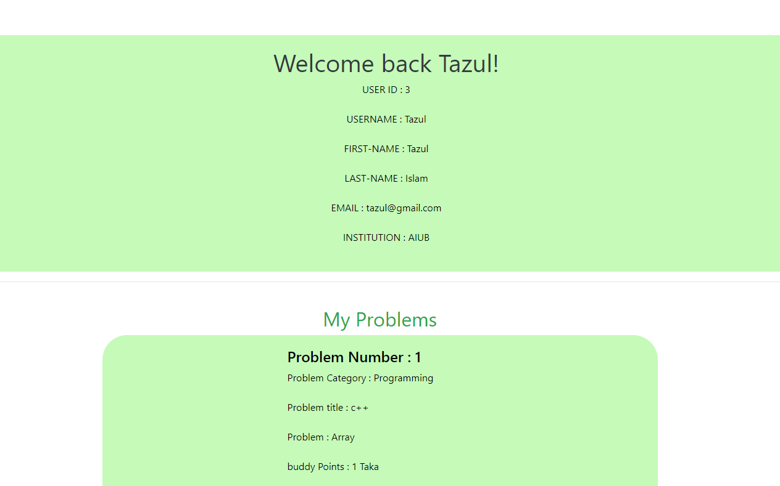

Figure-4 (Profile)

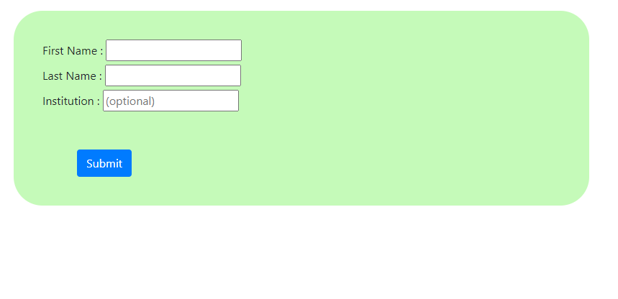

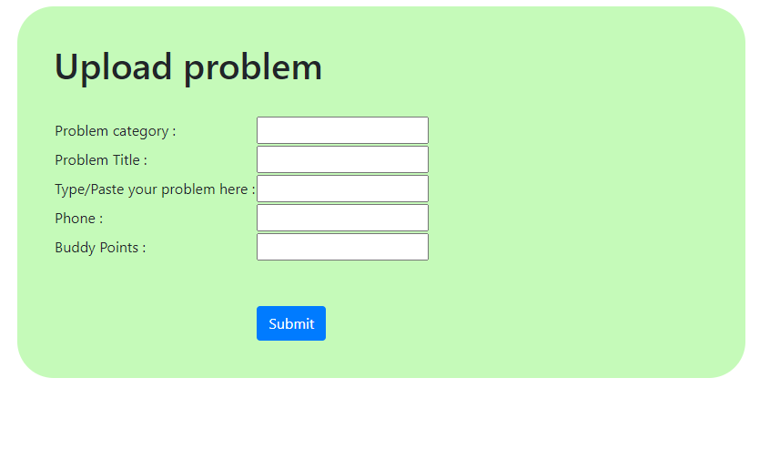

Figure-5 (Upload Problems)

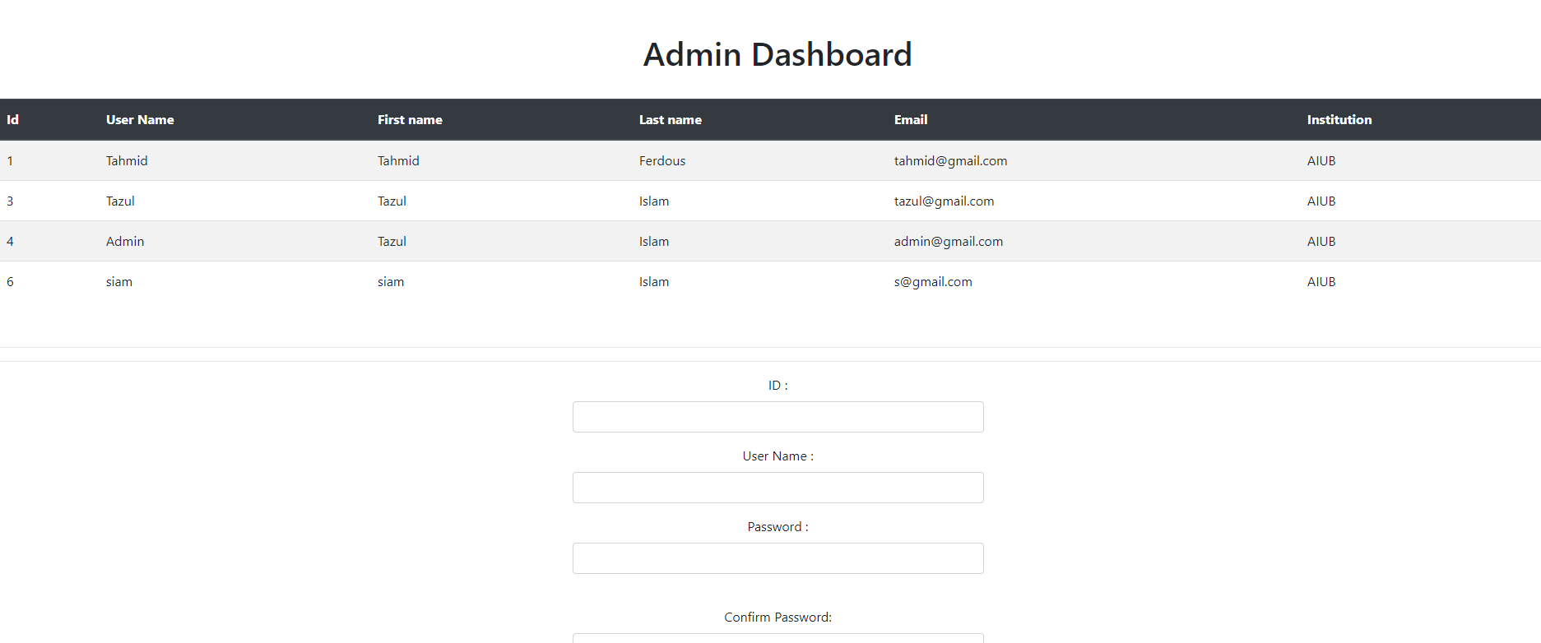

Figure-6 (Admin Panel)

## Project Requirements

* Total Development Time: 6 months.
* Total Working Hours needed: 24×(31+31+30+31+30+31) = 24×184 = 4416.
* 2,921 Hours for development
* 1,095 hours for Testing & Debugging
* 2 weeks for revision
* Cost: 1,50,000 BDT
* Resources

Accessories = 80,000 BDT

Domain = 10,000 BDT/ month

Total Estimated Budget = (1,50,000 + 10,000 +80,000) BDT = 240000 BDT

# FEATURES NOT TO BE TESTED

* Edit User Profile (Personal Information)
* Edit Admin Profile (Personal Information)
* Networking Testing
* Interconnection between database table
* Language (Default language is English)

# TESTING APPROACH

## Testing Levels

The testing for the proposed system will include unit testing. system integration testing and acceptance testing. Most of the testing will be done by the test manager and the development team will also participate.

**Unit testing:**

Unit testing will be performed by using white box testing method and the testing will be done by the developer. Then it will be approved by the development team leader .it must be provided by the programmer to the team leader before unit testing will be accepted. All the information of this testing will be also provided to the test person. Under unit testing there will be Control Flow Testing, Data Flow Testing, domain Flow Testing. In our system, the developer will select a particular part of an extensive program to set the testing path and Test cases represented by the control graph of the program. In our system, the developer will choose a specific section of a large program to set the testing path and test cases, which are represented by the program's control graph. In our system, the developer will search for anomalies (Defined and then defined again, Undefined but referenced, defined but not referenced) and it will be under the Data Flow Testing. In Domain Testing the developer will identify domains from the source code.

**System Testing:**

This testing will be performed by the test manager and development team leader with individual developer if needed. Program will enter into system or integration test after all critical defect have been corrected. It will be typically tested from a customer perspective and should test functional and nonfunctional requirements of this software.

**Acceptance testing**:

Acceptance testing will be performed by the actual end user with the assistance of the test manager and development team leader.

## Test Tools

**Selenium testing tool**

package basicPhase;

import org.openqa.selenium.By;

import org.openqa.selenium.WebDriver;

import org.openqa.selenium.chrome.ChromeDriver;

import io.github.bonigarcia.wdm.WebDriverManager;

public class URL_Visit{

public static void main(String[] args) throws InterruptedException {

WebDriverManager.chromedriver().setup();

WebDriver driver=new ChromeDriver();

driver.get("https://thefinancialexpress.news/");

Thread.sleep(3000);

driver.findElement(By.xpath("//header/section[1]/div[1]/button[1]/*[1]")).click();

Thread.sleep(2000);

driver.findElement(By.xpath("//span[contains(text(),'Economy')]")).click();

Thread.sleep(5000);

driver.findElement(By.xpath("//header/section[1]/div[1]/button[1]/*[1]")).click();

Thread.sleep(1000);

driver.findElement(By.xpath("//body/div[@id='__nuxt']/div[@id='__layout']/div[1]/div[2]/aside[1]/div[1]/nav[1]/div[1]/div[2]/a[1]/button[1]/*[1]")).click();

Thread.sleep(1000);

driver.findElement(By.xpath("//body/div[@id='__nuxt']/div[@id='__layout']/div[1]/div[2]/aside[1]/div[1]/nav[1]/div[1]/div[2]/div[1]/div[1]/a[1]")).click();

Thread.sleep(1000);

driver.findElement(By.xpath("//a[contains(text(),'Bangladesh seeks GSP support from Germany to face ')]")).click();

Thread.sleep(5000);

driver.findElement(By.xpath("//header/section[1]/div[1]/button[1]/*[1]")).click();

Thread.sleep(1000);

driver.findElement(By.xpath("//span[contains(text(),'Economy')]")).click();

Thread.sleep(5000);

driver.findElement(By.xpath("//header/section[1]/div[1]/button[1]/*[1]")).click();

Thread.sleep(1000);

driver.findElement(By.xpath("//body/div[@id='__nuxt']/div[@id='__layout']/div[1]/div[2]/aside[1]/div[1]/nav[1]/div[1]/div[2]/a[1]/button[1]/*[1]")).click();

Thread.sleep(1000);

driver.findElement(By.xpath("//body/div[@id='__nuxt']/div[@id='__layout']/div[1]/div[2]/aside[1]/div[1]/nav[1]/div[1]/div[2]/div[1]/div[1]/a[2]")).click();

Thread.sleep(1000);

driver.findElement(By.xpath("//a[contains(text(),'World economy to top $100 trillion in 2022 for fir')]")).click();

Thread.sleep(1000);

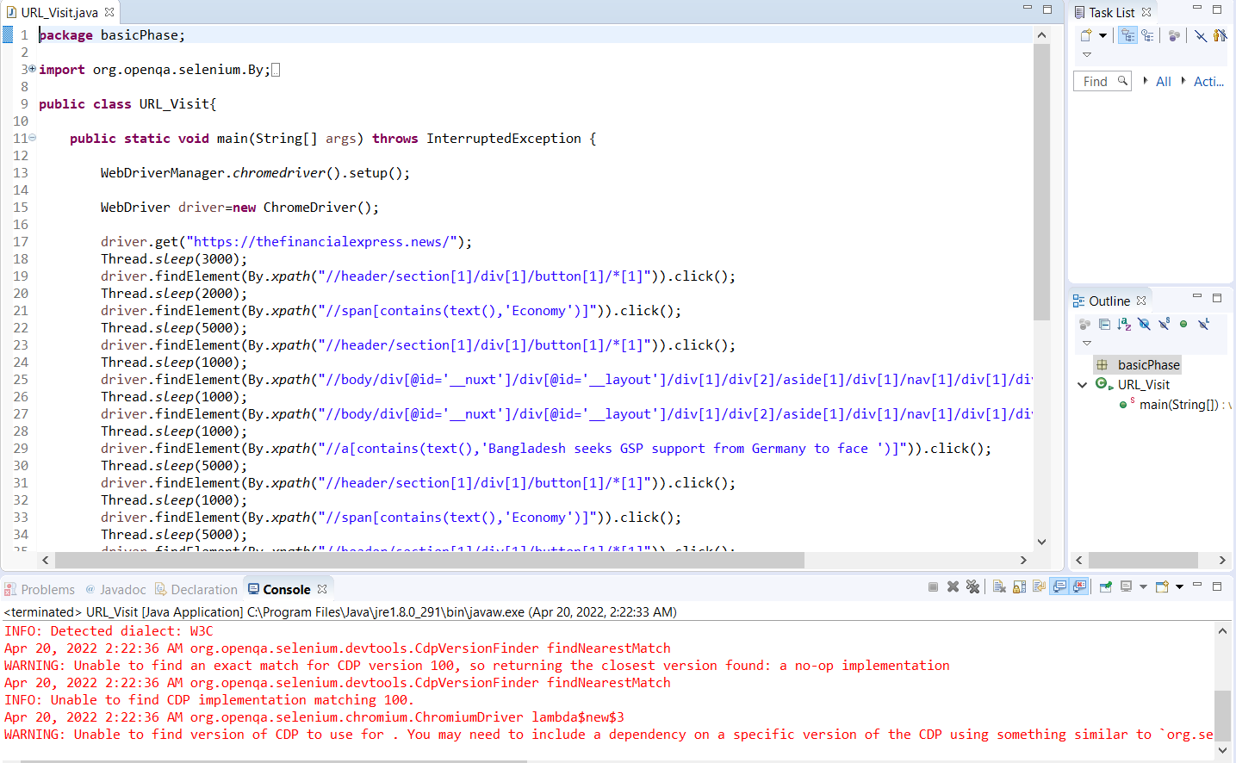

Figure-7 (Command)

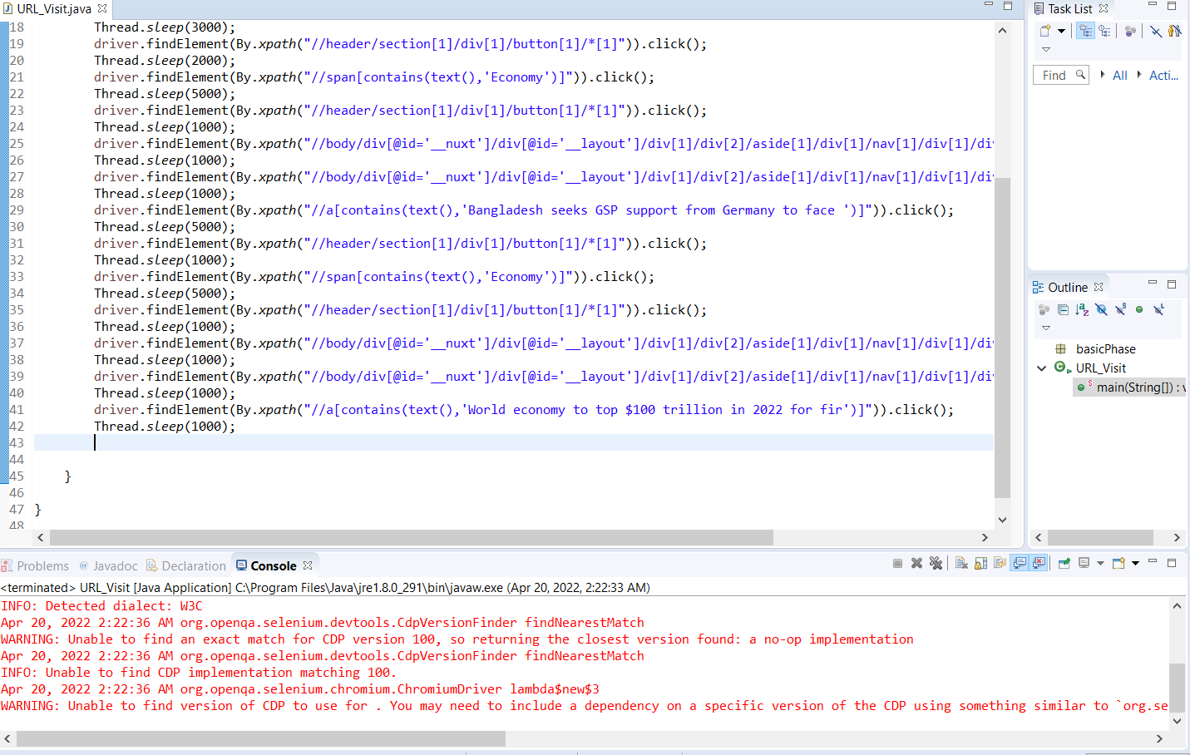

Figure-8 (Run the Command)

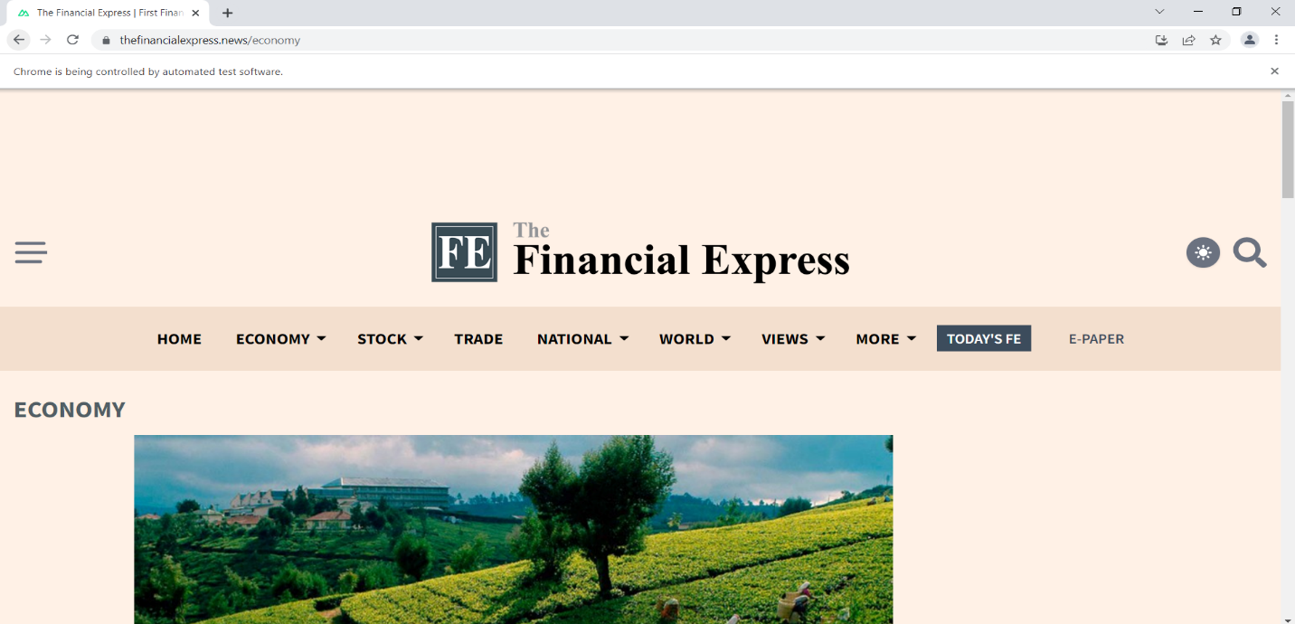



Figure-9 (Output of showing Page Economy)

**6.3 Meetings**

|  |  |  |
| --- | --- | --- |
| **Meetings Date** | **Meeting Criteria** | **Object** |
| 16-04-22 | Checking of system features and quality attributes | * Check the Functional & Nonfunctional requirements * System’s working process |
| 18-04-22 | Error & Bug Solving | * After detecting bugs list down * Solve the bugs * Preparation for safety |
| 20.-04-22 | Conclusive | * Check the listed documentation * Recheck the requirements * Run the full system |

# TEST CASES/TEST ITEMS

|  |  |  |  |  |  |
| --- | --- | --- | --- | --- | --- |
| Project Name: Study-Buddy | | | Test Designed by: QA Engineer | | |
| Test Case ID: FR_1 | | | Test Designed date:18-04-22 | | |
| Test Priority (Low, Medium, High): High | | | Test Executed by: Tazul | | |
| Module Name: Registration Session | | | Test Execution date:18-04-22 | | |
| Test Title: Register with personal information | | |  | | |
| Description: Test registration session | | |  | | |
| Precondition (If any): User must have personal information(name,email) | | | | | |
| Test Steps | Test Data | Expected Results | | Actual Results | Status (Pass/Fail) |
| 1. Go to the website 2. Enter sign up 3. Enter personal information 4. Click submit | F.Name-Tazul  L.Name-Islam  Email-tazul@gmail.com  Institute-AIUB | Register successfully & Creation of profile | | As expected, | Pass |
| Post Condition: User is validated with database. The account session details are logged in the database. | | | | | |

|  |  |  |  |  |  |
| --- | --- | --- | --- | --- | --- |
| Project Name: Study-Buddy | | | Test Designed by: QA Engineer | | |
| Test Case ID: FR_2 | | | Test Designed date:18-04-22 | | |
| Test Priority (Low, Medium, High): High | | | Test Executed by: Sufian | | |
| Module Name: Login Session | | | Test Execution date:18-04-22 | | |
| Test Title: Verify login with valid username and password | | |  | | |
| Description: Test application login page | | |  | | |
| Precondition (If any): User must have valid username and password | | | | | |
| Test Steps | Test Data | Expected Results | | Actual Results | Status (Pass/Fail) |
| 1. Go to the application 2. Enter username 3. Enter password 4. Click submit | Username: Sufian  Password: 123 | log in to the System | | As expected, | Pass |
| Post Condition: User is validated with database and successfully logs in to account. The account session details are logged in the database. | | | | | |

|  |  |  |  |  |  |
| --- | --- | --- | --- | --- | --- |
| Project Name: Study-Buddy | | | Test Designed by: QA Engineer | | |
| Test Case ID: FR_3 | | | Test Designed date:18-04-22 | | |
| Test Priority (Low, Medium, High): High | | | Test Executed by: Irina | | |
| Module Name: Upload Problems | | | Test Execution date:19-04-22 | | |
| Test Title: User upload problem documents with own profile | | |  | | |
| Description: Test if the problem is uploaded or not | | |  | | |
| Precondition (If any): User must have profile with own account | | | | | |
| Test Steps | Test Data | Expected Results | | Actual Results | Status (Pass/Fail) |
| 1. Login to account 2. Enter Information 3. Upload Problem 4. Submit | Username:  Problem document – C++ | Uploaded | | As expected, | Pass |
| Post Condition: Document is stored in the Database | | | | | |

|  |  |  |  |  |  |
| --- | --- | --- | --- | --- | --- |
| Project Name: Study-Buddy | | | Test Designed by: QA Engineer | | |
| Test Case ID: FR_3 | | | Test Designed date:18-04-22 | | |
| Test Priority (Low, Medium, High): High | | | Test Executed by: Dipty | | |
| Module Name: Logout | | | Test Execution date:19-04-22 | | |
| Test Title: Logout from the account | | |  | | |
| Description: Test after logout back to the dashboard session | | |  | | |
| Precondition (If any): User must Login to the account | | | | | |
| Test Steps | Test Data | Expected Results | | Actual Results | Status (Pass/Fail) |
| 1. Login to account 2. Logout | Username:  Dipty  Pass-123 | Logout | | As expected, | Pass |
| Post Condition: Go to the Dashboard | | | | | |

|  |  |  |  |  |  |
| --- | --- | --- | --- | --- | --- |
| Project Name: Study-Buddy | | | Test Designed by: QA Engineer | | |
| Test Case ID: FR_3 | | | Test Designed date:18-04-22 | | |
| Test Priority (Low, Medium, High): High | | | Test Executed by: Dipty | | |
| Module Name: Logout | | | Test Execution date:19-04-22 | | |
| Test Title: Logout from the account | | |  | | |
| Description: Test after logout back to the dashboard session | | |  | | |
| Precondition (If any): User must Login to the account | | | | | |
| Test Steps | Test Data | Expected Results | | Actual Results | Status (Pass/Fail) |
| 1. Login to account 2. Logout | Username:  Dipty  Pass-123 | Logout | | As expected, | Pass |
| Post Condition: Go to the Dashboard | | | | | |

# ITEM PASS/FAIL CRITERIA

* With valid information, the registration should be done.
* The user profile and admin profile should be created.
* A valid user name and password should be given.
* The problem should be uploaded without any compiling errors.
* The page transaction should be smooth.
* The test cases should be properly documented.
* All reports should be maintained.
* All problem documents should be viewed by the valid user account.
* Item pass fail criteria depends on Test Cases. 100% defect free system is not possible.
* If 98% or above 98% test cases are pass then the system is passed
* If below 98% test cases are pass then the system is failed

# TEST DELIVERABLES

* Test documentation
* Test Plan
* Test Strategy
* Test Scenario
* Test Designs
* Test Cases
* Bug report
* Test Summary Report
* Test data
* Test Status report
* Test Scripts

# STAFFING AND TRAINING NEEDS

The way to approach staffing and training will vary from project to project. If this section is part of a Master Test Plan, should indicate at what points in the project lifecycle different skills and numbers of staff are needed. If this is an Iteration Test Plan, should focus mainly on where and what training might occur during the Iteration.

The developers and testers will need to be trained on the basic operations of the EDI interface. The test team often requires the support and skills of other team members not directly part of the test team. Make sure of arranging in the plan for appropriate availability of System Administrators, Database Administrators, and Developers who are required to enable the test effort.

# RESPONSIBILITIES

|  |  |  |
| --- | --- | --- |
| Name | Role | Responsibilities |
| Tazul | Team Manager | * Develop the strategy * Check the test report |
| Sufian | Project Manager | * Test Planning * Required Interactions with customers. |
| Irina | Senior Test Engineer | * Writing test plans and creating test cases for the product. |
| Dipty | Associate Test Engineer | * Execute the testing. * Create test data and status reports for team lead. |

# TESTING SCHEDULE

The following testing activities have been scheduled into the project plan: The project plan timetable defines the particular dates and hours for each task. The individuals necessary for each procedure are also specified in the project's timeframe and plan to be taken into

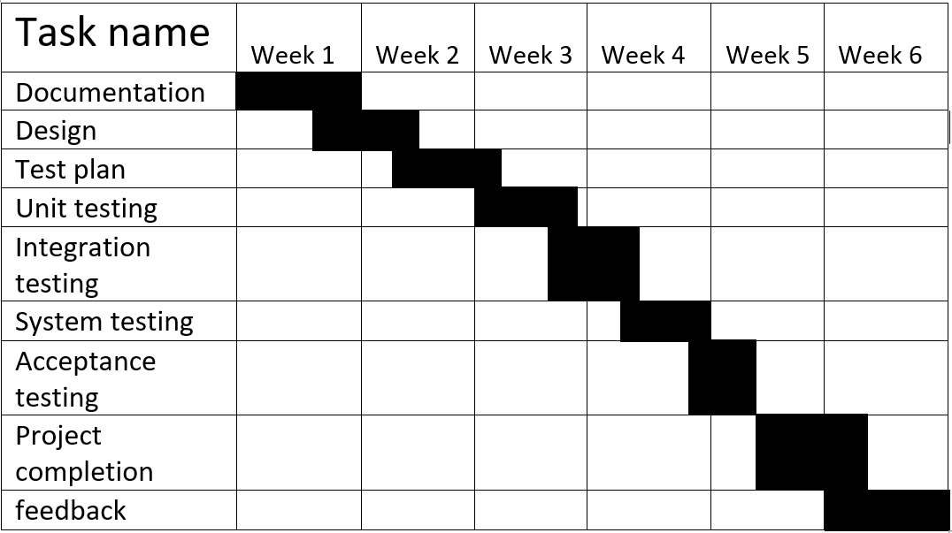

# PLANNING RISKS AND CONTINGENCIES

* The risks associated with a project include a variety of financial, scheduling, human resource, and customer-related difficulties. Schedule slippage is a critical project risk.
* Consumers are more receptive to downloading an app if they see its worth. Even before customers download the software, positive ratings and reviews alert prospective purchasers. Additionally, app store algorithms take user reviews and ratings into account when ranking applications.
* Technical hazards include possible concerns with style, implementation, interoperability, testing, and maintenance.
* Application and system architecture
* Business Risk

The majority of software engineering initiatives are inherently dangerous due to the number of possible difficulties. Managers may categorize risk based on their experience with past software engineering projects.

# APROVALS

|  |  |
| --- | --- |
| **Position** | **Assigned** |
| Project Manager | * Test case |
| Development Management | * Integration test |
| Design Manager | * Interface |
| Test team Lead | * Acceptance system |
| Test Engineer | * Functionality test |
| Reassigned Sales | * Data flow test |
| QA Manager | * Review test case |
| Client | * System testing |